Regular expression location specific example

1. Paragraph content marking method in Word

* P<file://test.docx>[1], representing the first paragraph in the document (text.docx).
* P[1-] indicates the first paragraph and subsequent paragraphs.
* P[-5], denotes the fifth paragraph and the preceding paragraph.
* P[1-5], representing paragraphs 1 through 5.
* P[1]C[5-10] : indicates the text consisting of characters 5 through 10 in the first paragraph.
* P[1]C[5]-P[2]C[10], indicates the text consisting of the fifth character in paragraph 1 through the tenth character in paragraph 2.

Example diagram:

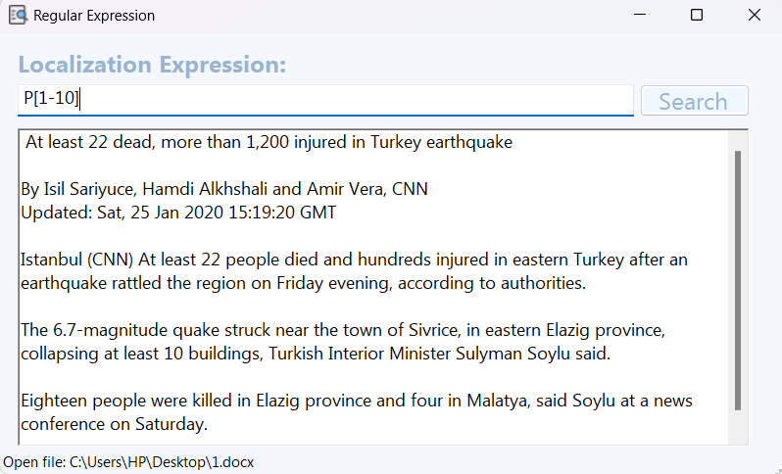

To include files in location information (Don’t need to select local files):

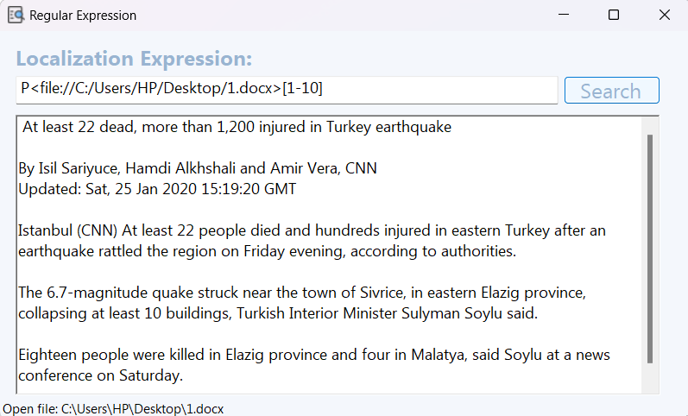

1. Table content marking method in Word

* T<file://test.docx>[1], which represents the first table in the document (text.docx).
* T[1], indicating the first table.
* T[1-], indicates the first table and subsequent tables.
* T[-2], indicates the second table and previous tables.
* T[1-2], indicates table 1 through table 2.
* T[1]TR[1-2], rows 1 to 2 in the first table.
* T[1]TR[1]TC[1-2], row 1, column 1, column 2, Table 1.
* T[1]TR[1]TC[2]P[1]C[2], which is the second character in row 1, column 2, paragraph 1, and Table 1.
* T[1]TR[1]TC[2]P[1]C[2-5], indicating the second character to the fifth character in the first column, row, column, paragraph, and table.
* T[1]TR[1]TC[2]P[1]C[2]-P[2]C[3], indicating the second character in paragraph 1, row 1, column 2, to the third character in paragraph 2, in Table 1.

Example diagram:

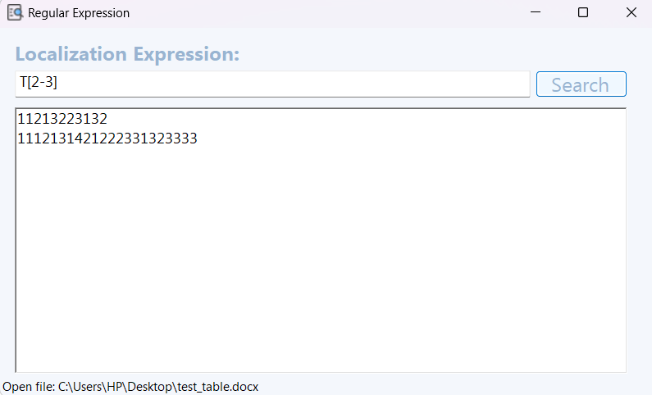

3. Cell content identification method in Excel

* S<file://test.xml>"Mysheet"! A5 represents the cell at the intersection of column A and row 5 in the form named "Mysheet" in the document (test.xml).
* S"Mysheet"!A3:D8 represents the range of cells between columns A through D and rows 3 through 8 in the form "Mysheet".

Example diagram:

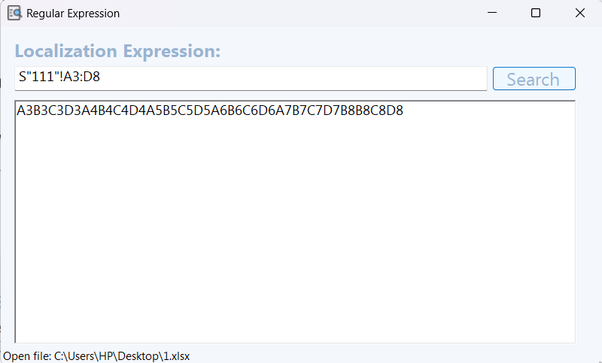

4. Slide Content Labeling Methods in PowerPoint

* SL<file://test.ppt>[1], the first slide in the file (file://test.ppt).
* SL[1-5], representing slides 1 through 5.
* SL[1-] indicates the first slide and subsequent slides.
* SL[-5] indicates the fifth slide and previous slides.

Example diagram:

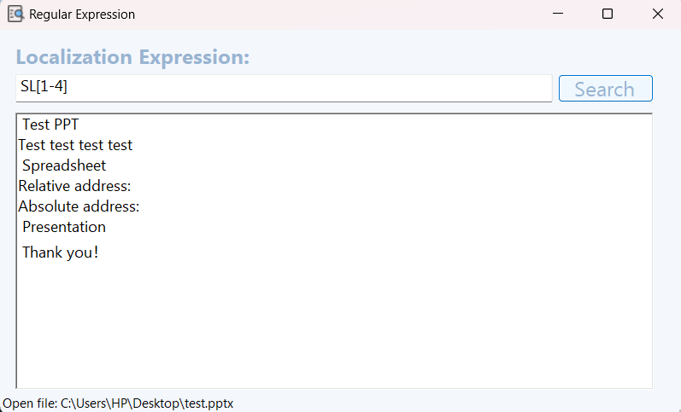

5. Object Content Identification Methods in Ofd

* PG<file://test.ofd>[1], page 1 of the file (file://test.ofd).
* PG[1-], the number of pages 1 and after.
* PG[-3], indicates the number of pages before page 3.
* PG[1-3], pages 1 to 3.
* PG[1]O[1-5], indicates objects 1 through 5 on page 1.

Example diagram:

